Influences:

1. <https://www.behance.net/gallery/68257851/Tofu-Design-Website-Identity?tracking_source=search_projects_recommended%7Cui%20portfolio%20website>
2. <https://www.behance.net/gallery/76872863/rebrending-internet-magazina-akvanet-2018?tracking_source=project_owner_other_projects>
3. <https://www.behance.net/gallery/94193665/Interior-accessories?tracking_source=search_projects_recommended%7Cui%20website>

Project Description: This project is creating a website to showcase the work that i’ve done so far as well as tell the internet little things about myself.

Mockups!

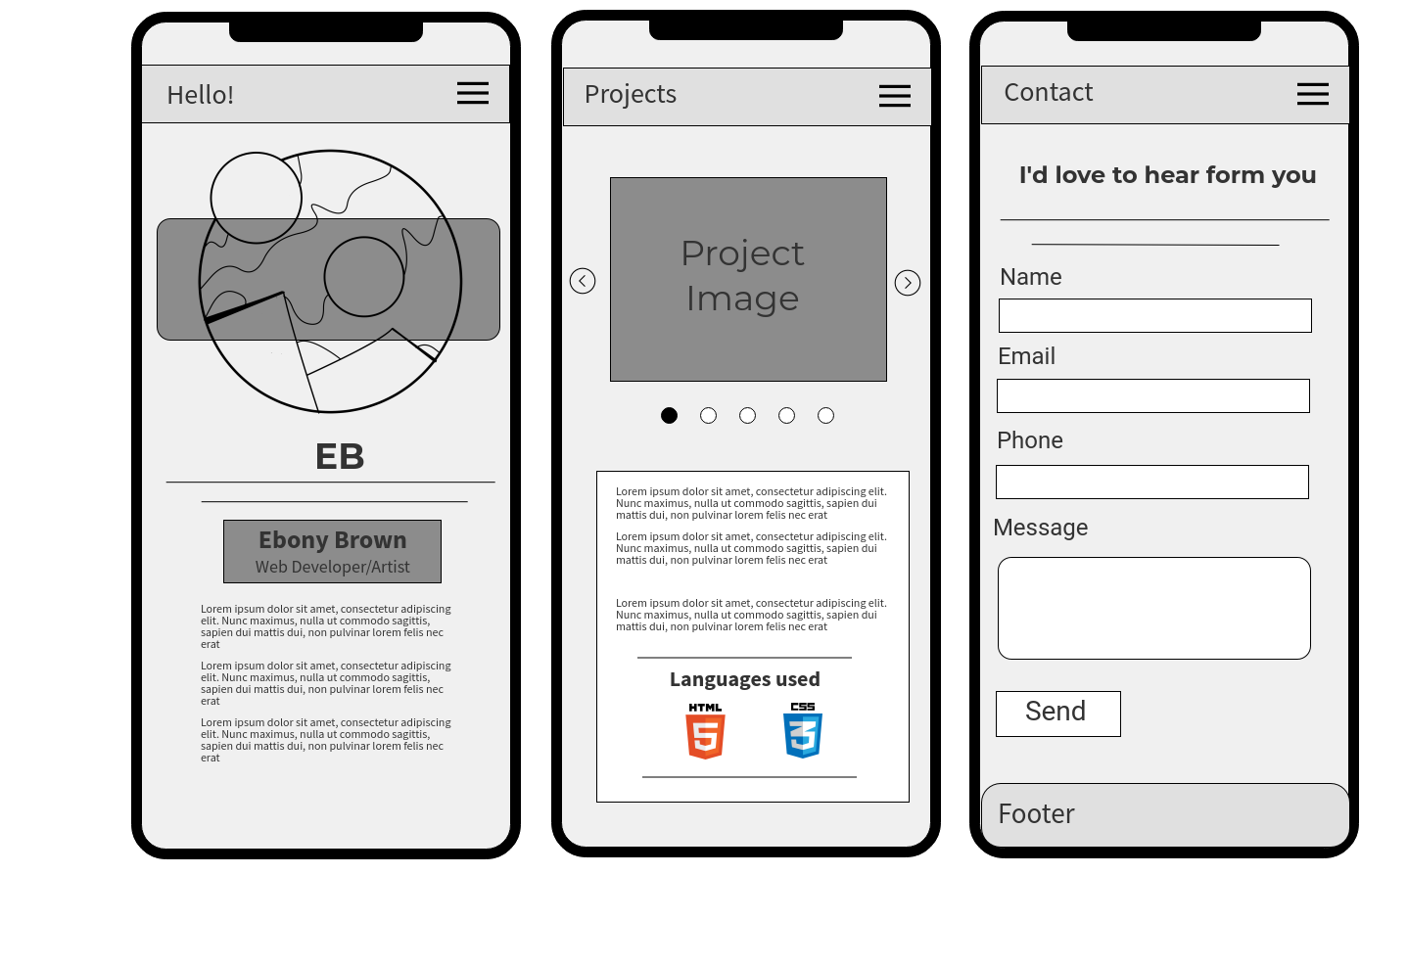

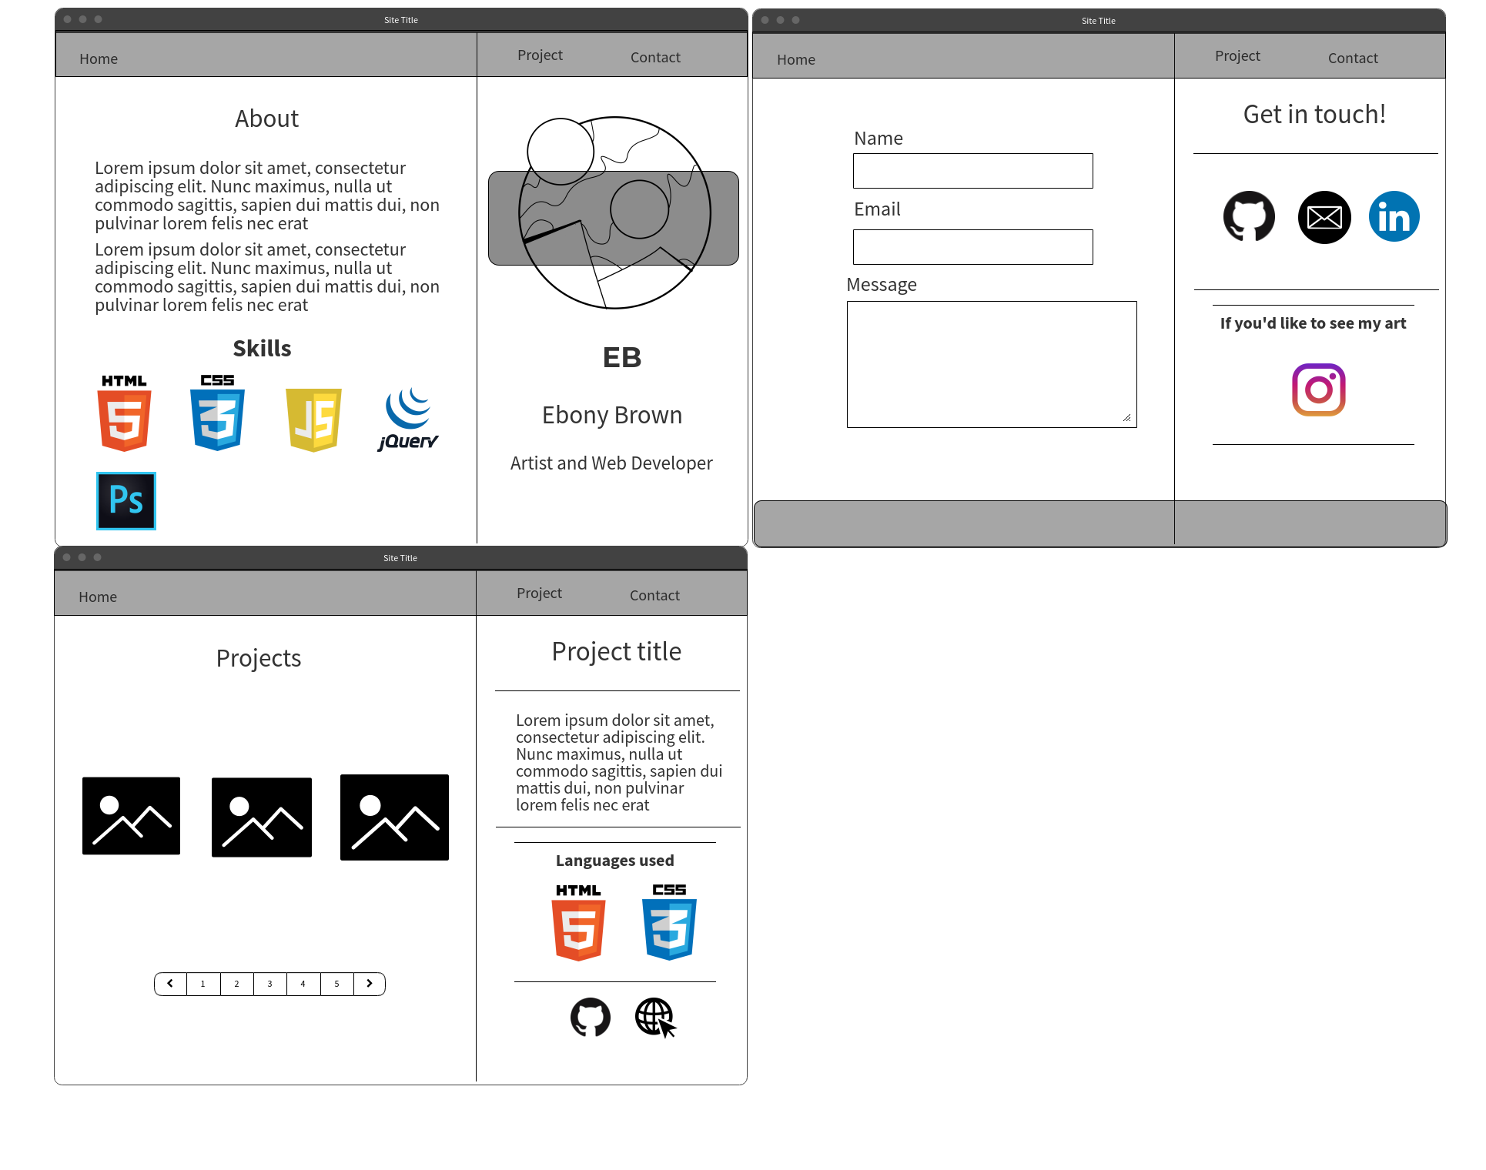

Desktop

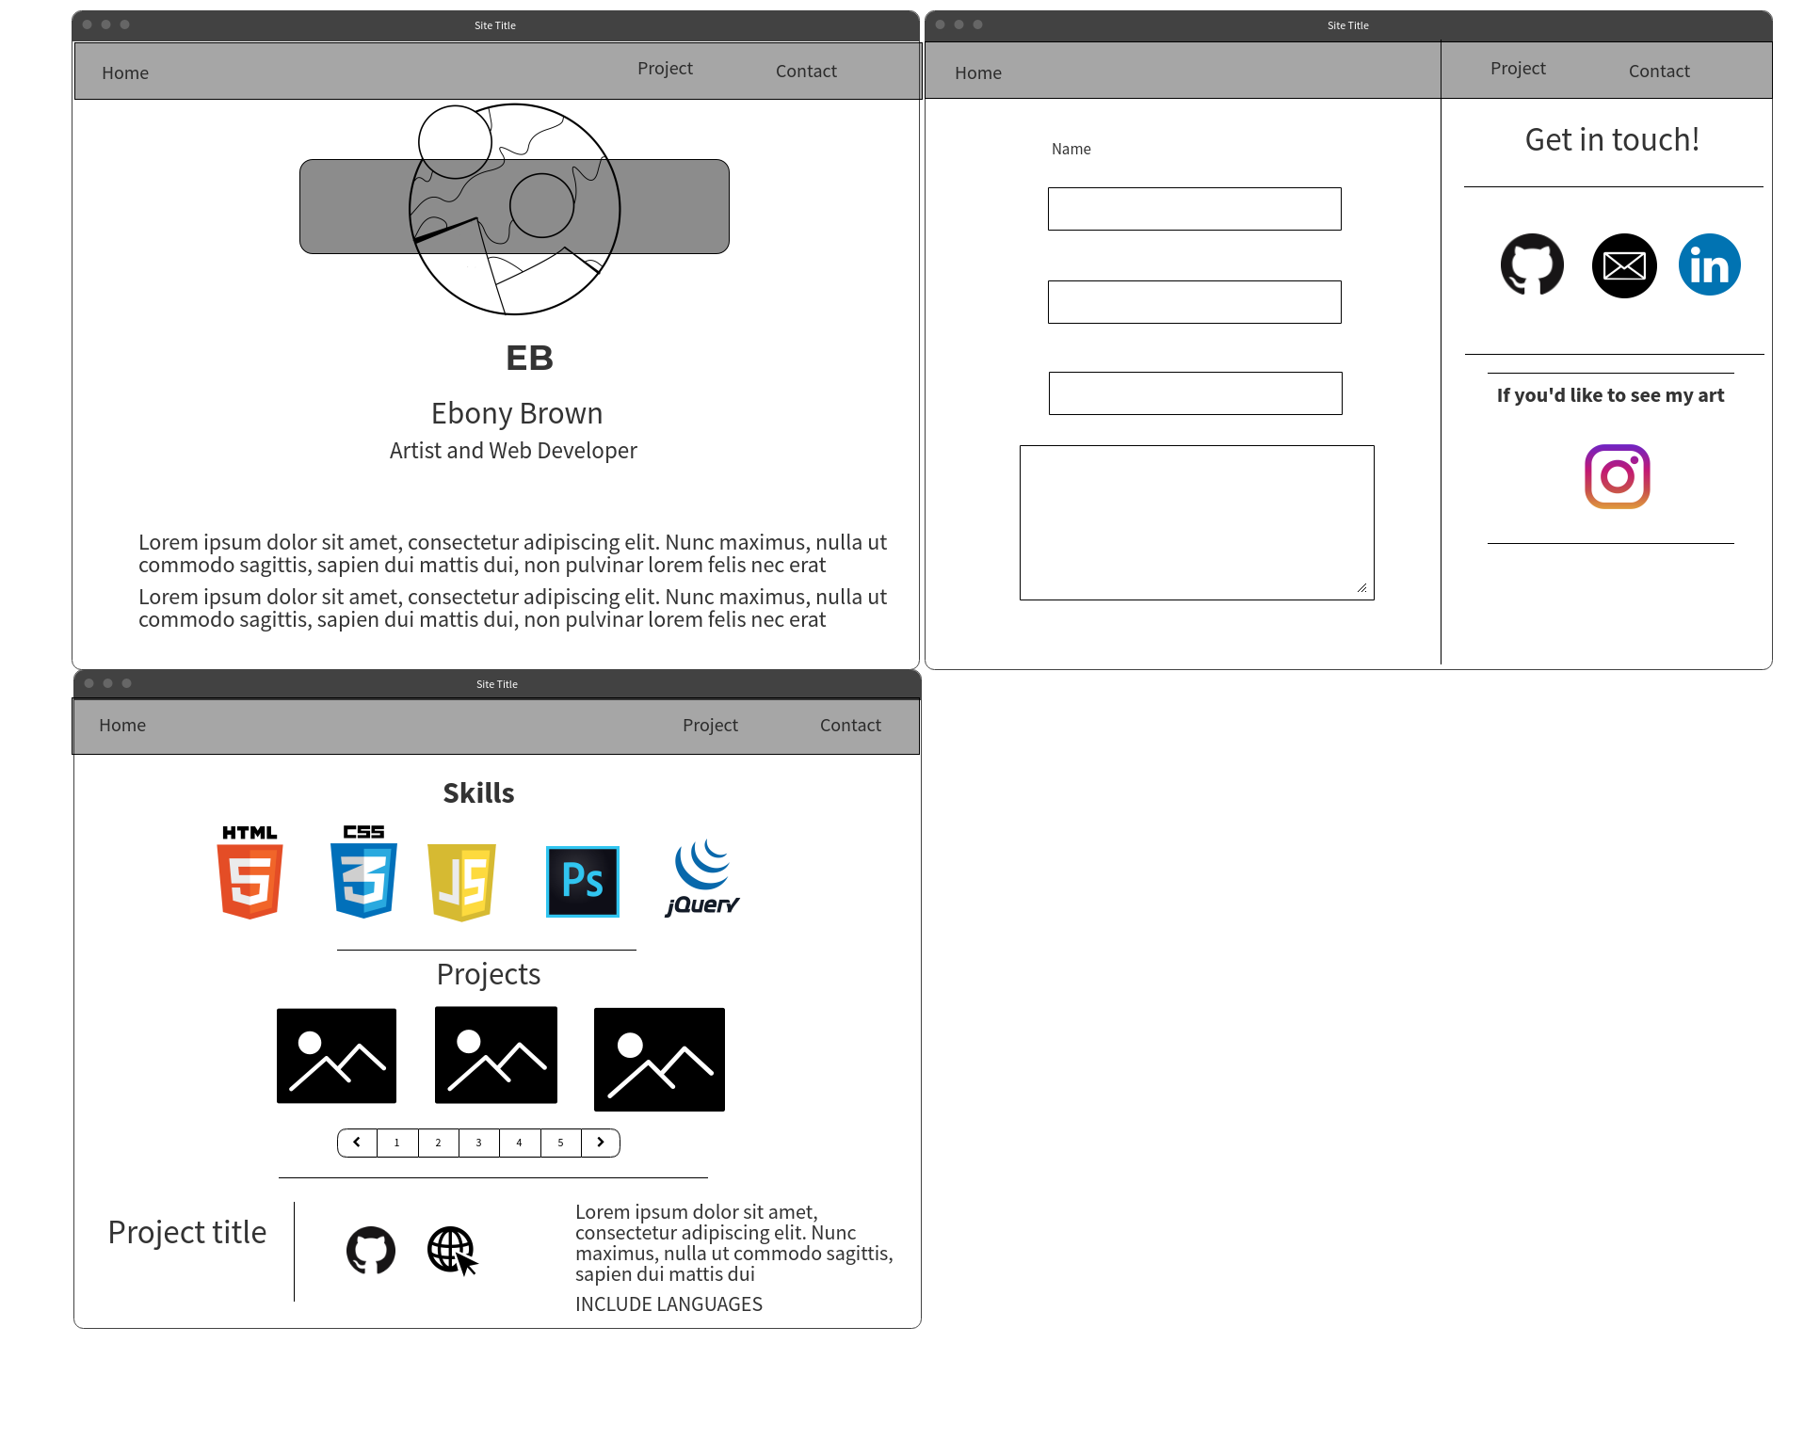

Post MVP Tablet changes

Time Priority Matrix

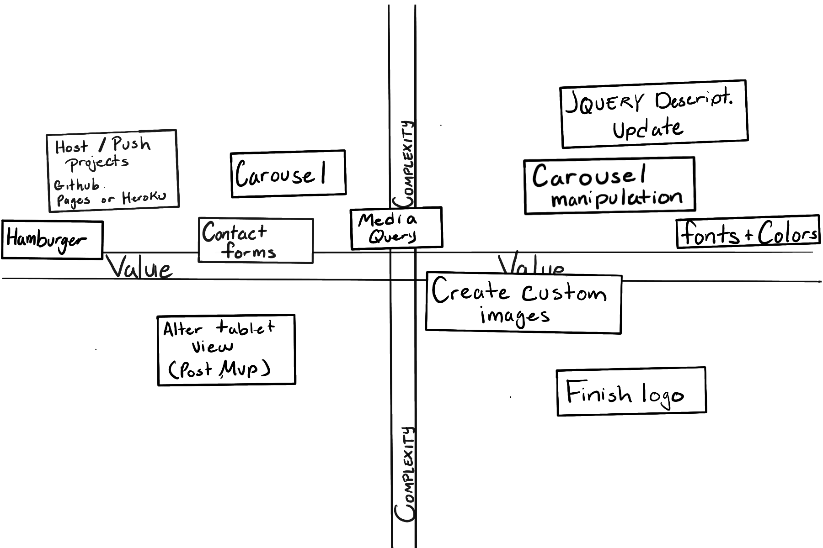

MVP

|  |  |  |  |  |
| --- | --- | --- | --- | --- |
| Feature | Priority | Estimated Time | Time Invested | Actual Time |
| Mobile Recreation | H | 6 hrs | 3hrs 58mins | N/A |
| Hamburger Menu | H | 3hr | 1hr 20mins | N/A |
| Fonts + colors | M | 2hr | N/A | N/A |
| Carousel | H | 6hrs | 1hr 15mins | N/A |
| Contact form functionality | H | 2.5hrs | 2 hr | N/A |
| Carousel manipulation | M | 1.5hr | N/A | N/A |
| Jquery Update | M | 1.5hr | 3 hr 26mins | N/A |
| Push Project | H | 2.5hr | N/A | N/A |
| Projects Live | H | 2hr | N/A | N/A |
| Desktop recreation | H | 3hrs | 0 hr 48 mins | N/A |
| Total | - | 30 hrs | 9hrs 49mins | N/A |

POST MVP

|  |  |  |  |  |
| --- | --- | --- | --- | --- |
| Feature | Priority | Estimated Time | Time Invested | Actual Time |
| Finish logo, original photos | L | 3hr | N/A | N/A |
| Alter tablet view to match tablet mockup | H | 1hr | N/A | N/A |
| Total | - | 4hr | N/A | N/A |